|  |  |
| --- | --- |
| /Course Name | ITD 2313 – Script Programming |
| Instructor | Mr. Pranger |
| Student Name | Trey Mobley |
| Due date | 06/09/2021 |
| /Grade | <grade earned here> |
| Grading Comments | <instructor comments here> |

Project # 1

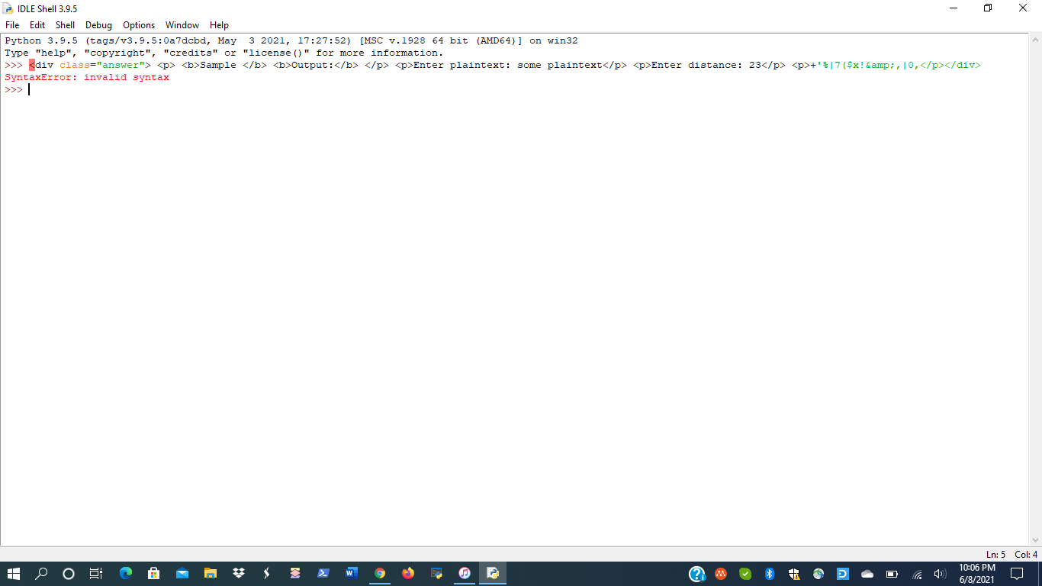

Project # 9

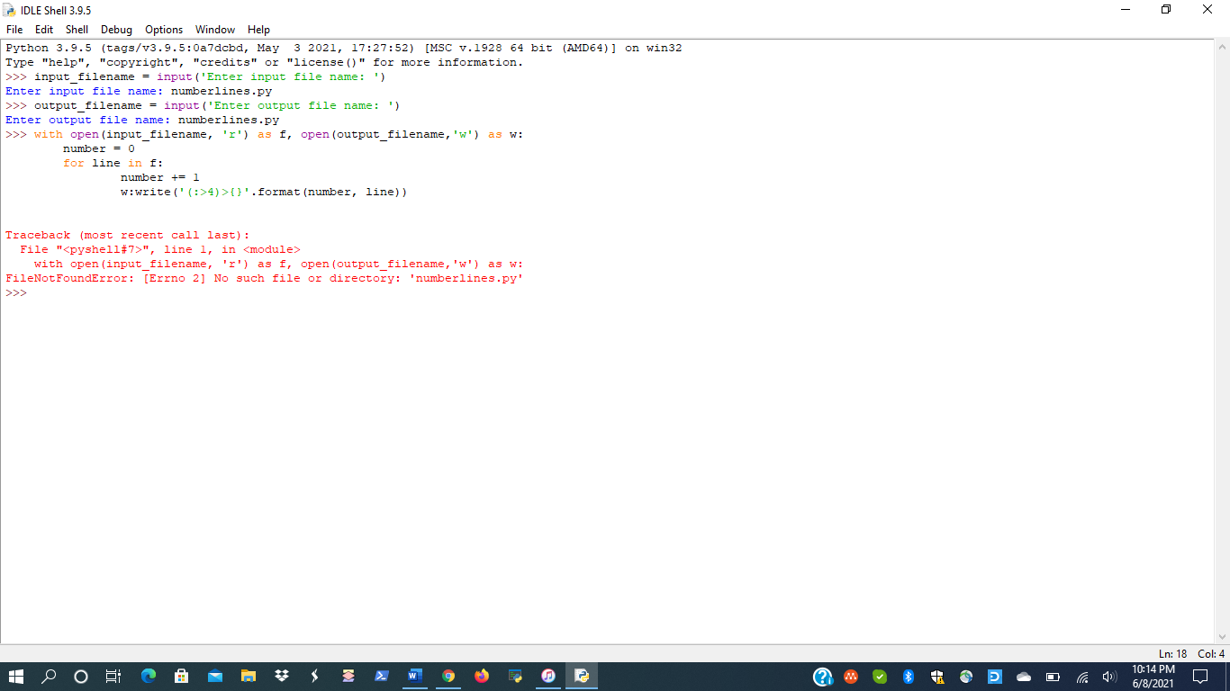

Project # 12